**EXCEL- 3**

**Given Supermarket data for 3 months. Using pivot tables create dashboard and charts as shown below. Feel free to use your own creativity and come up with more charts and use different colors.**

**Total sales vs Product line**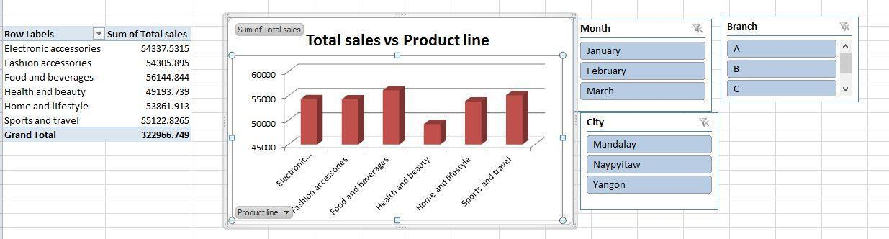

**Total gross income vs city**

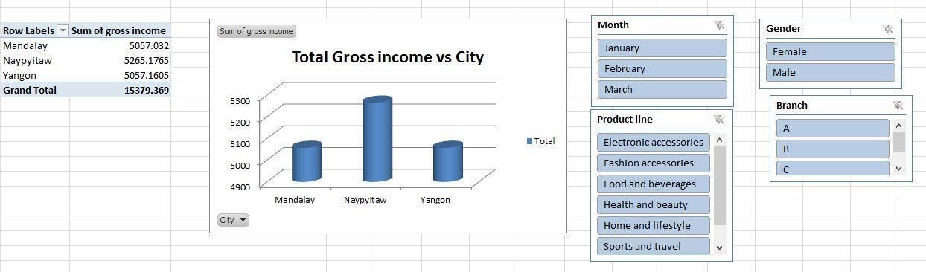

**Total quantity per branch**

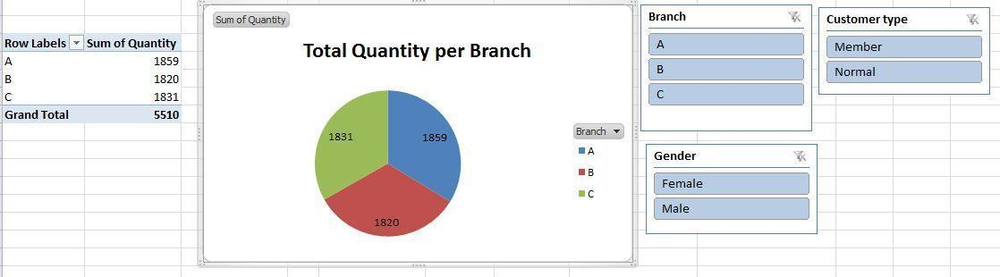

**Total sales vs Month**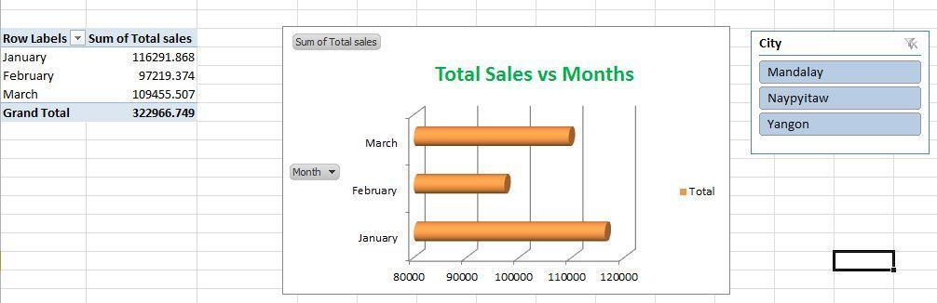

**DashBoard**

